Entry page:

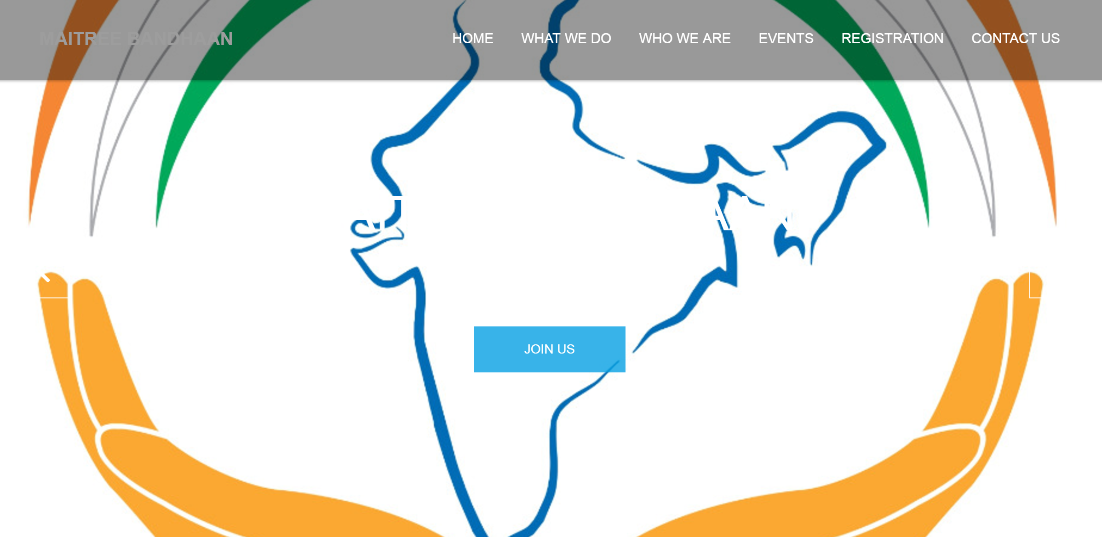

Instead of Logo, it should keep rolling below attached photos: Logo should be on left top corner in place of name mentioned currently.

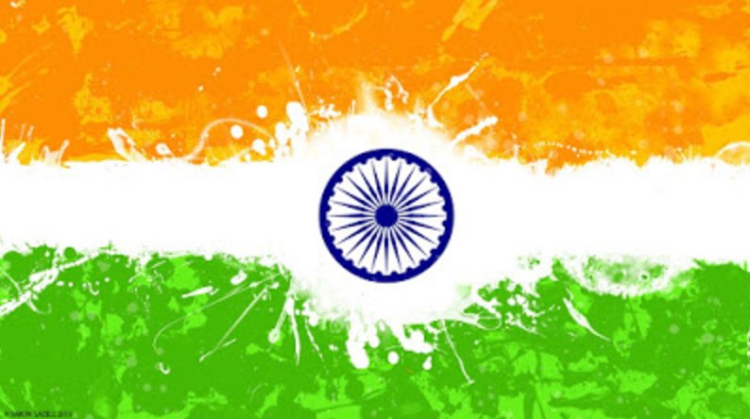

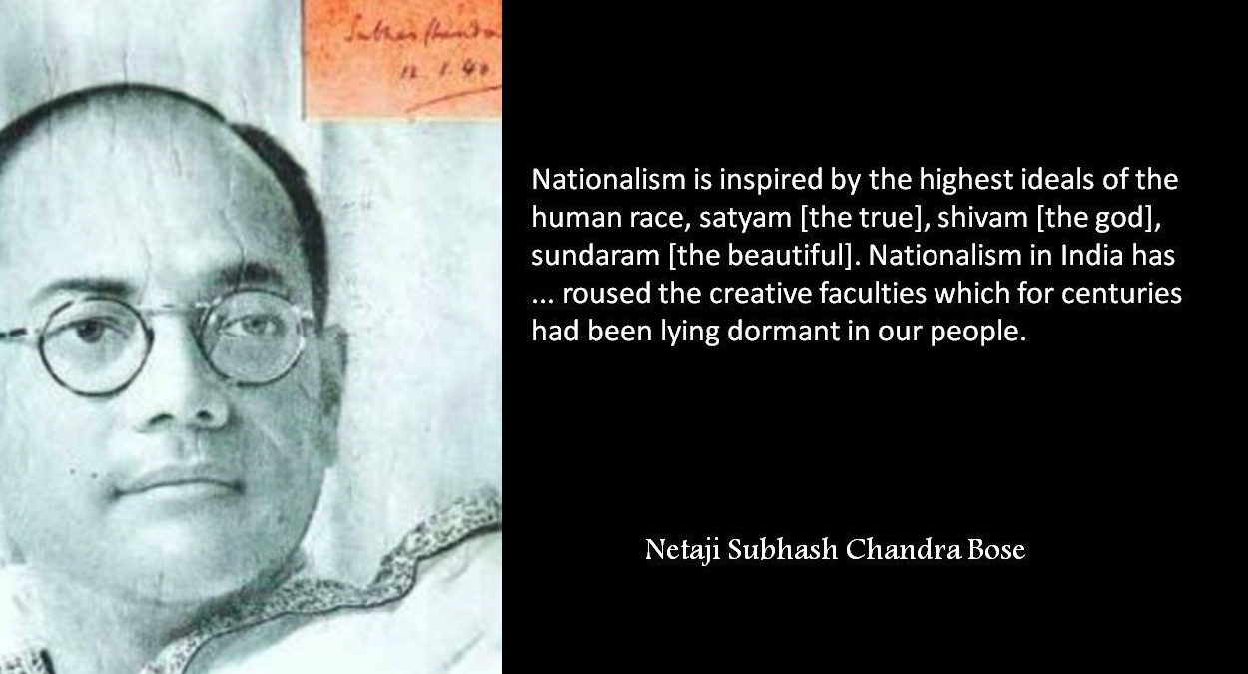

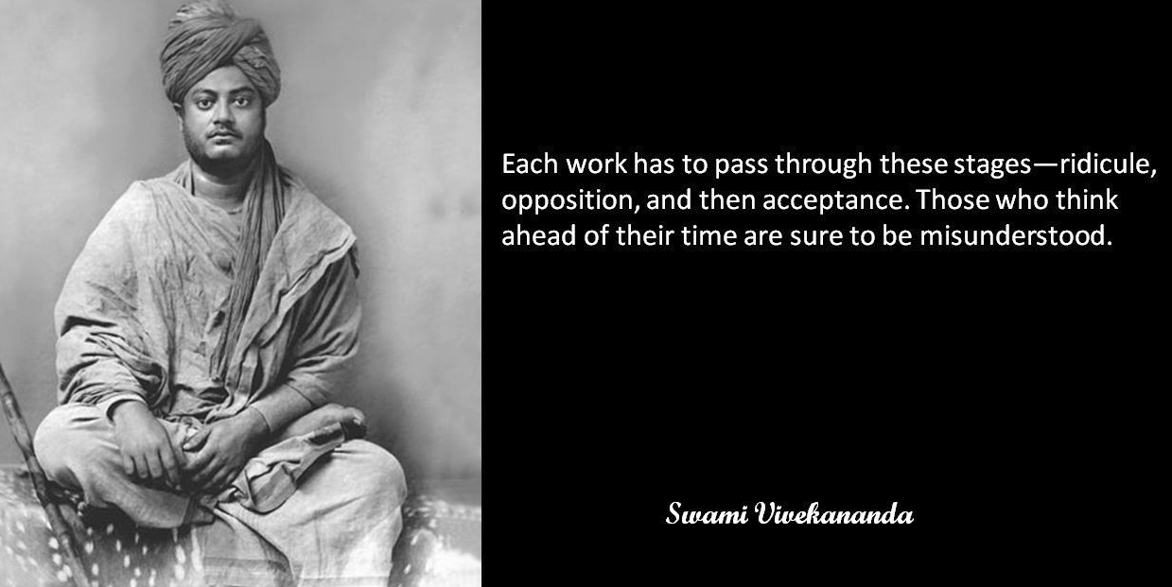

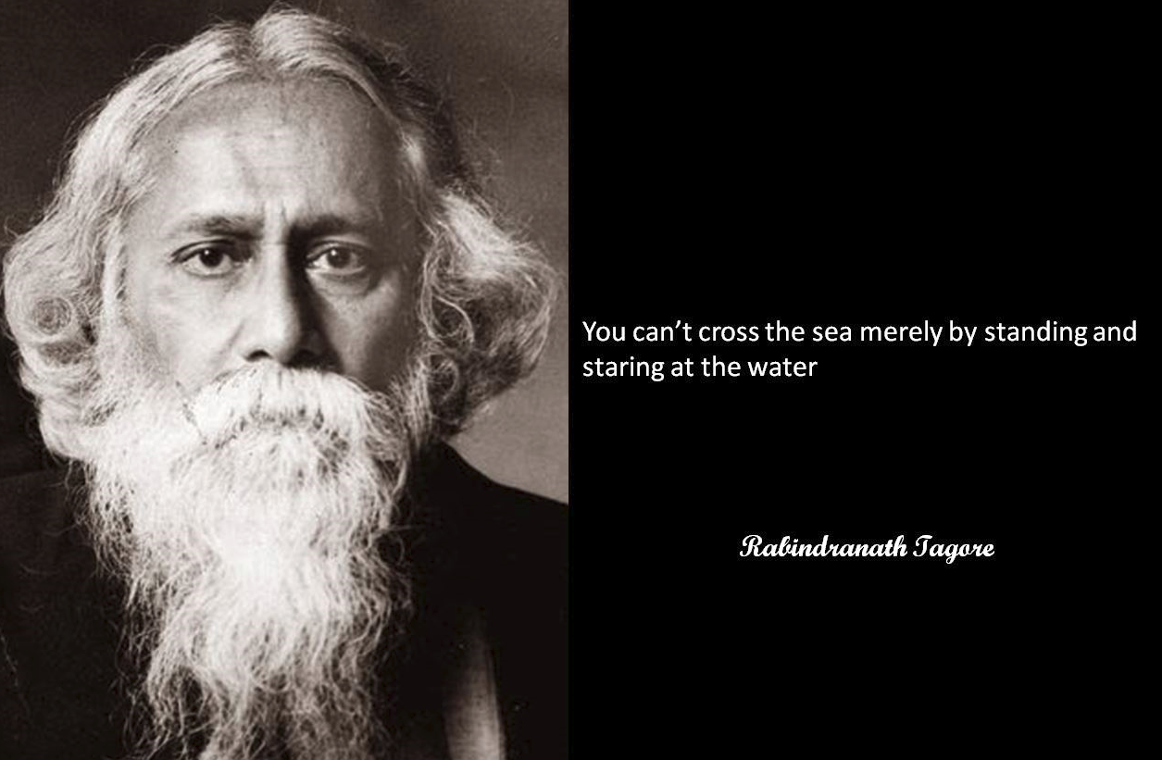

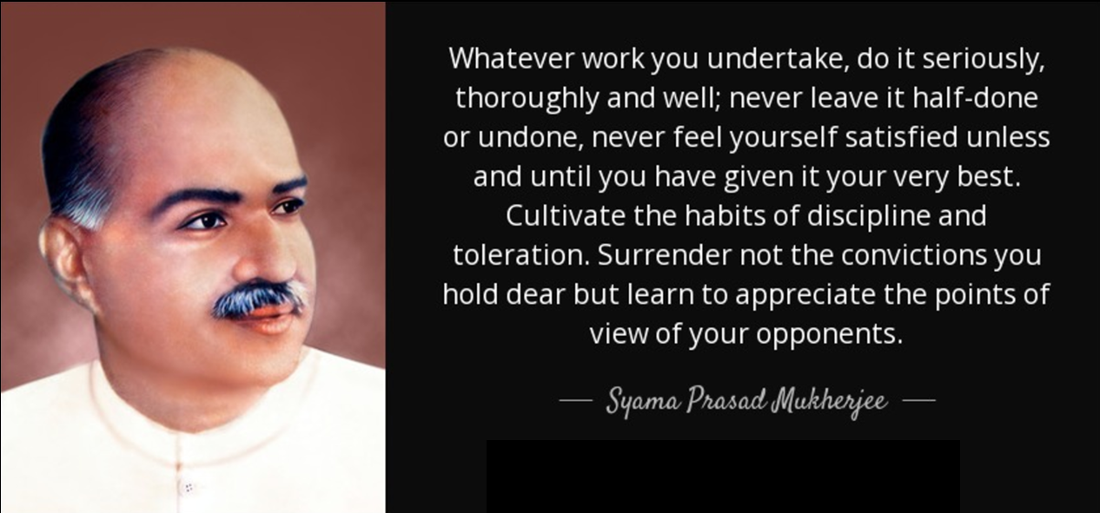

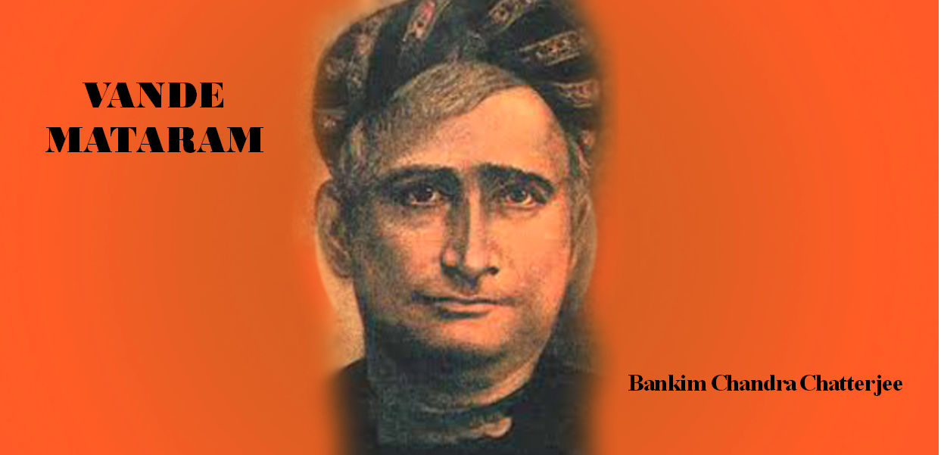

Instead of “JOIN US” it should be marked as “ENTER”.

Please delete “HOME” or replace it with “WHO WE ARE”

“WHO WE ARE” tab should be before “WHAT WE DO”.

Once you click “WHO WE ARE”, the following write up should come:

**History of Bengal and Bengalis:**

The name of Bengal is derived from the ancient kingdom of Banga. It is believed that a tribe called Bang that settled in the area around the year 1000 BCE are known as Bengalis.

Archaeologists have discovered remnants of a 4,000 years old Chalcolithic civilization in the greater Bengal region and believe the finds are one of the earliest signs of settlement in the region.

Bengalis are the third largest ethnic group in the world after Han Chinese and Arabs.

Bengal has played a major role in history. At times an independent regional empire, the historical region was a leading power in Southeast Asia with extensive trade networks. In antiquity, its kingdoms were known as seafaring nations. Bengal was known to the Greeks as Gangaridai, notable for mighty military power. It was described by the Greek's historian that [Alexander the Great](https://en.wikipedia.org/wiki/Alexander_the_Great) withdrew from the [South East Asia](https://en.wikipedia.org/wiki/South_east_Asia), anticipating a counterattack from an alliance of Gangaridai. Later writers noted merchant shipping links between Bengal and [Roman Egypt](https://en.wikipedia.org/wiki/Roman_Egypt).

Bengali nationalism is rooted in the expression of pride in the history and cultural heritage of Bengal.

The first social and religious reform movements such as the Brahmo Samaj and Ramakrishna Mission arose in Bengal, as did national leaders and reformers such as Raja Ram Mohan Roy, Sri Aurobindo, Ramakrishna Paramhansa and Swami Vivekananda.

Bengali literature, poetry, religion, science and philosophy underwent a massive expansion with the works of Bankim Chandra Chatterjee, Debendranath Tagore, Michael Madhusudan Dutt, Sharat Chandra Chattopadhyay, Rabindranath Tagore, Satyendra Nath Bose, Jagdish Chandra Bose and Shyama Prasad Mukherjee. The Calcutta-based Indian National Association is the earliest political organizations in India.

Bengal was one of the epicenters of India’s struggle for freedom. One of the first organized movements against the British rule was organised in Bengal. Bengal has produced plenty of freedom fighters and revolutionaries who laid down their lives for the sake of their country.

**Maitree Bandhaan**

Maitree or maitrī in Sanskrit means benevolence, loving-kindness, friendliness.

Bandhan is also an ancient Sanskrit word which found in Rig Veda, where this word means someone who is feeling bonded because of emotions and tying or someone tied with emotions with a group of peoples.

It’s unfortunate that in current days, Bengalis are often identified as either a communist or a Trinamool supporter or land of black magics by locals of other states. But do we really want to have that identity?

We must remind people that we Bengalis are from that land which is a birth place of first non-European to win the Nobel Prize in Literature in 1913, Rabindranath Tagore, Swami Vivekananda the first person who represented India and Hinduism in The Parliament of the World's Religions in 1893 at the Art Institute of Chicago, freedom fighters like Netaji Subhash Chandra Bose, Khudiram Bose, Binoy Badal Dinesh, Masterda Surya Sen, Chittaranjan Das, Sri Aurobindo and many more.

Bengalis are from that land which is also a birthplace of religious gurus like Ramakrishna Paramahansa, Sri Chaitanya Mahaprabhu, Srila Prabhupada, Srimat Swami Pranabanandaji Maharaj.

**Formation:**

Few energetic probashi bengalees living in Bangalore for few years now felt that it’s important that we all should unite under one single platform.

Keeping this objective in mind, this handful of probashi bengalees started distributing sweets at the time of Durga immersions in Ulsoor and started interacting with all Bengali associations in Bangalore.

Finally on 26th March 2017, first meeting was conducted where decision was taken to form a registered organization MAITREE BANDHAAN which will be the largest platform for all probashi Bengalis residing in Bengaluru and engage with social activities as a community.

**Objective:**

The motto adopted is "Brotherhood and Service". The aim is for the community to share the Happiness and Sorrows of all the members and do impactful social work for the society we are living in.

MAITREE BANDHAAN connects with all bengali associations of Bengaluru and their members families and build a strong network and develop a strong bondness.

Main objective of MAITREE BANDHAAN is to connect with all probashi benglis from all section of the society and bring them together. Strengthen the community and build the largest platform for all probashi Bengalis and actively participate in social cause along with locals.

**Believe:**

UNITED we stand, DIVEDED we fall.

**Registration:**

On 28th July, 2017 MAITREE BANDHAAN officially got registered and launched in 26th August, 2017.

UPLOAD THE VIDEO TEASER

Once you click **“WHAT WE DO”,** following writing should be there:

MAITREE BANDHAAN was officially inaugurated on 26th August, 2017. Guests of the events were:

Srimat Swami Bishwapremanandaji Maharaj of Bharat Sevashram Sangha

Shri Anjan Ray, Founder and Director of Ray Chemicals

Shri Himadri Nandi, Founder and Managing Director of MROTEK

**INAUGURATION EVENT PHOTOS**

**Once you click “EVENTS”, following details should come:**

**Seva work in Karunashraya:**

Karunashreya a joint project by Rotary club Indiranagar, Indian Cancer Society and Hospice Trust.

They provide free professional palliative care for advanced stage cancer patients who are BEYOND CURE. Maitree Bandhaan donated food grains for patients:

**PHOTOS OF SEVA WORK**

**Mother's Day @Kidwai Memorial Oncology:**

**PHOTOS OF SEVA WORK**

**Once you click “REGISTRATION”, following form should pop up:**

Name:

Mobile number:

Address:

Email id:

Location:

Email id and mobile number should be verified by sending OTP.

Once verified, then it should connect to payment gateway. My suggestion for payment gateway is “CC Avenue”.

This payment gateway is having zero setup fee but there is a charge of Rs.1,200 per year (1st year free) as annual software upgradation charges. As this is free setup for us, it levies 2% service charge which is Rs.2 when any member is paying their membership fee which is again very nominal.

Once you click “CONTACT US”, it should show the below:

**Governing Bodies:**

Name, respective designation and small brief of that person should be mentioned

**Working Committee:**

Name and Department/responsibility managing should be mentioned

Email: [maitreebandhaan.bangalore@gmail.com](mailto:maitreebandhaan.bangalore@gmail.com)

Facebook: <https://www.facebook.com/maitreebandhaan>

**MAITREE BANDHAAN**

1/A, Teachers Colony, 80 Feet Road,

1st Stage, 2nd Block,

HBR Layout,

BANGALORE,

KARNATAKA, 560043

Contact: +91 88613 00466/99723 06445/93428 28694